SIMATS ENGINEERING
ASSESSMENT TOOL 2

COURSE NAME: Database Management Systems
COURSE CODE: CSA05

COURSE OUTCOME COVERED
CO3: Analyze relational databases using functional dependencies, normalization
(1NF to 5NF), and key constraints to identify redundancy and ensure data integrity.
(BL2, BL3)
Activity Tool : Case Study (Medium)
Assessment Tool Weightage: 30%

QUESTIONS

- Analyze the case: An online shopping platform stores Order(OrderID, CustID, CustName, ProdID, ProdName, Qty, Price). Identify FDs and normalize to 3NF.
ANSWER:
Online Shopping Platform — Normalize to 3NF
Relation
Order(OrderID, CustID, CustName, ProdID, ProdName, Qty, Price)
Functional Dependencies
Assume one order can contain multiple products.
- OrderID → CustID, CustName
- ProdID → ProdName, Price
- (OrderID, ProdID) → Qty
Therefore:
Candidate Key: (OrderID, ProdID)
1NF
All attributes contain atomic values, so the relation is in 1NF.
2NF
There are partial dependencies:
- OrderID → CustID, CustName
- ProdID → ProdName, Price
Decompose:
ORDER
Order(OrderID, CustID, CustName)
PRODUCT
Product(ProdID, ProdName, Price)
ORDER_ITEM
OrderItem(OrderID, ProdID, Qty)
3NF
There are no transitive dependencies inside these relations.
Final 3NF:
- Order(OrderID, CustID, CustName)
- Product(ProdID, ProdName, Price)
- OrderItem(OrderID, ProdID, Qty)
Primary Keys:
- Order → OrderID
- Product → ProdID
- OrderItem → (OrderID, ProdID)

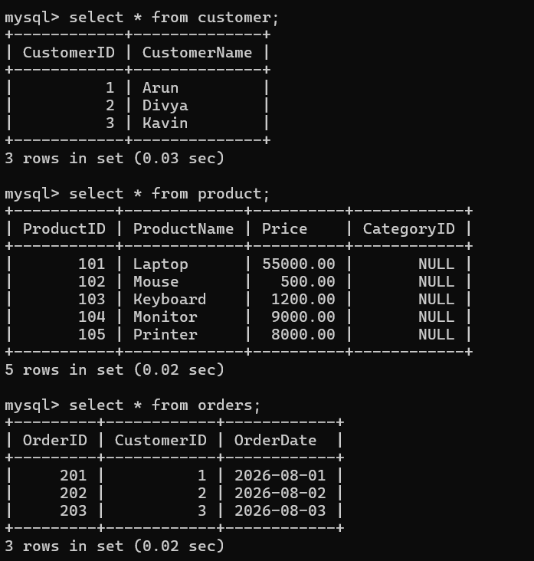
- A hospital maintains Patient(PID, PName, DocID, DocName, Specialization, WardNo, WardName). Identify anomalies and normalize to BCNF.
ANSWER:
Hospital — Normalize to BCNF
Relation
Patient(PID, PName, DocID, DocName, Specialization, WardNo, WardName)
Functional Dependencies
- PID → PName, DocID, WardNo
- DocID → DocName, Specialization
- WardNo → WardName
Candidate Key
PID
Problems / Anomalies
Update anomaly:
If a doctor's specialization changes, multiple patient records must be updated.
Insertion anomaly:
A doctor cannot be stored unless a patient is assigned to that doctor.
Deletion anomaly:
Deleting the last patient of a doctor may remove the doctor's information.
BCNF Decomposition
PATIENT
Patient(PID, PName, DocID, WardNo)
DOCTOR
Doctor(DocID, DocName, Specialization)
WARD
Ward(WardNo, WardName)
Each determinant is a candidate key in its relation.
Therefore, the decomposition is in BCNF.
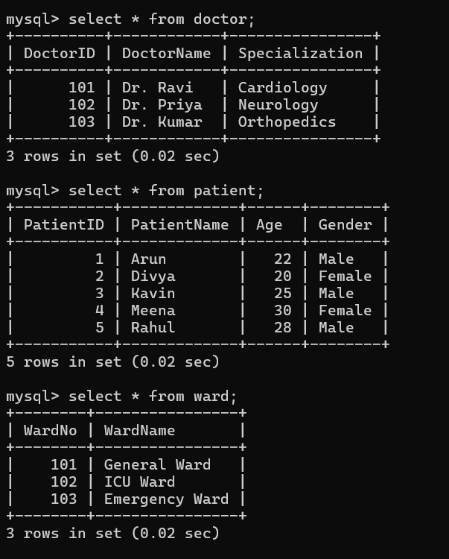
- Case study: A university stores Enrollment(SID, SName, CourseID, CourseName, Faculty, Grade). Analyze FDs and apply 2NF decomposition.
ANSWER:
Hospital — Normalize to BCNF
Relation
Patient(PID, PName, DocID, DocName, Specialization, WardNo, WardName)
Functional Dependencies
- PID → PName, DocID, WardNo
- DocID → DocName, Specialization
- WardNo → WardName
Candidate Key
PID
Problems / Anomalies
Update anomaly:
If a doctor's specialization changes, multiple patient records must be updated.
Insertion anomaly:
A doctor cannot be stored unless a patient is assigned to that doctor.
Deletion anomaly:
Deleting the last patient of a doctor may remove the doctor's information.
BCNF Decomposition
PATIENT
Patient(PID, PName, DocID, WardNo)
DOCTOR
Doctor(DocID, DocName, Specialization)
WARD
Ward(WardNo, WardName)
Each determinant is a candidate key in its relation.
Therefore, the decomposition is in BCNF.
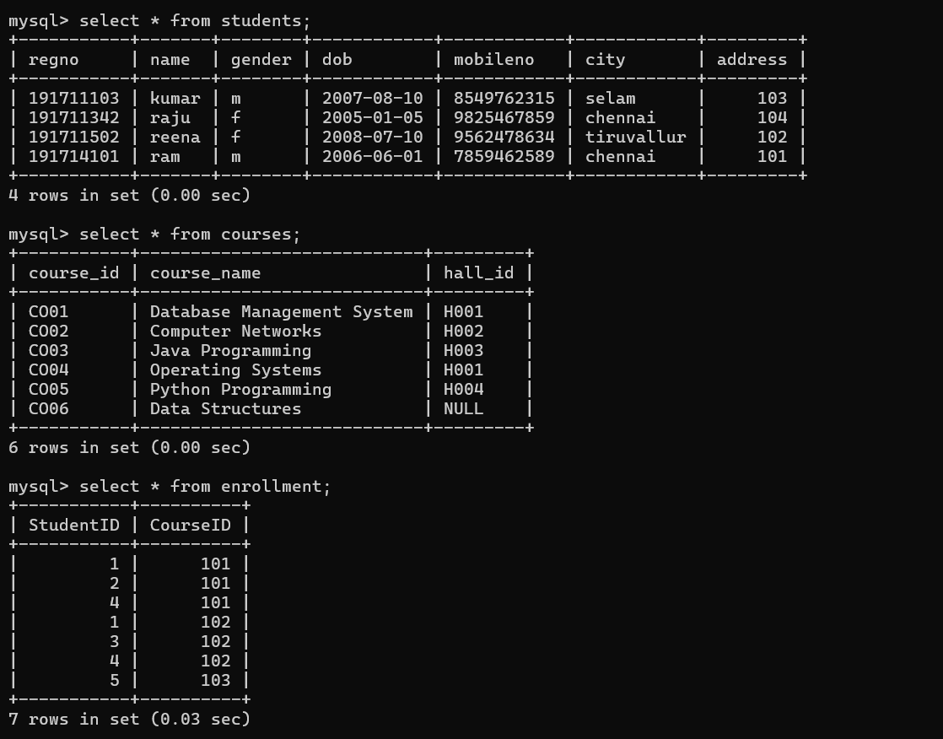
- Given the airline booking case: Booking(FlightNo, PassID, PassName, Seat, DeptCity, ArrCity, Date). Normalize up to BCNF.

ANSWER:

Airline Booking — Normalize to BCNF
Relation
Booking(FlightNo, PassID, PassName, Seat, DeptCity, ArrCity, Date)
Assume a passenger has one seat on a particular flight/date.
Functional Dependencies
- PassID → PassName
- FlightNo → DeptCity, ArrCity
- (FlightNo, Date, PassID) → Seat
If flight details are fixed for a flight:
FlightNo → DeptCity, ArrCity
Candidate Key
(FlightNo, Date, PassID)
Decomposition
PASSENGER
Passenger(PassID, PassName)
FLIGHT
Flight(FlightNo, DeptCity, ArrCity)
BOOKING
Booking(FlightNo, Date, PassID, Seat)
BCNF Check
- PassID is key in Passenger.
- FlightNo is key in Flight.
- (FlightNo, Date, PassID) is key in Booking.
Therefore, all relations satisfy BCNF.

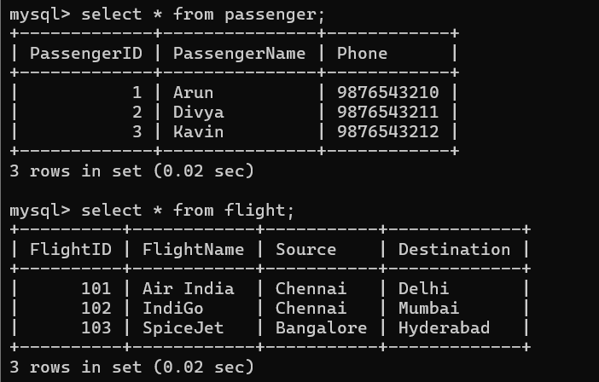
- Analyze an HR system schema for a multinational company. Identify all functional and transitive dependencies and normalize to 3NF.
ANSWER:
HR System — Normalize to 3NF
Consider:
Employee(EmpID, EmpName, DeptID, DeptName, ManagerID, ManagerName, JobID, JobTitle, Salary)
Functional Dependencies
- EmpID → EmpName, DeptID, ManagerID, JobID, Salary
- DeptID → DeptName, ManagerID
- ManagerID → ManagerName
- JobID → JobTitle
Candidate Key
EmpID
Transitive Dependencies
EmpID → DeptID → DeptName
EmpID → ManagerID → ManagerName
EmpID → JobID → JobTitle
These are transitive dependencies.
3NF Decomposition
EMPLOYEE
Employee(EmpID, EmpName, DeptID, ManagerID, JobID, Salary)
DEPARTMENT
Department(DeptID, DeptName, ManagerID)
MANAGER
Manager(ManagerID, ManagerName)
JOB
Job(JobID, JobTitle)
Now transitive dependencies are removed.
Therefore, the design is in 3NF
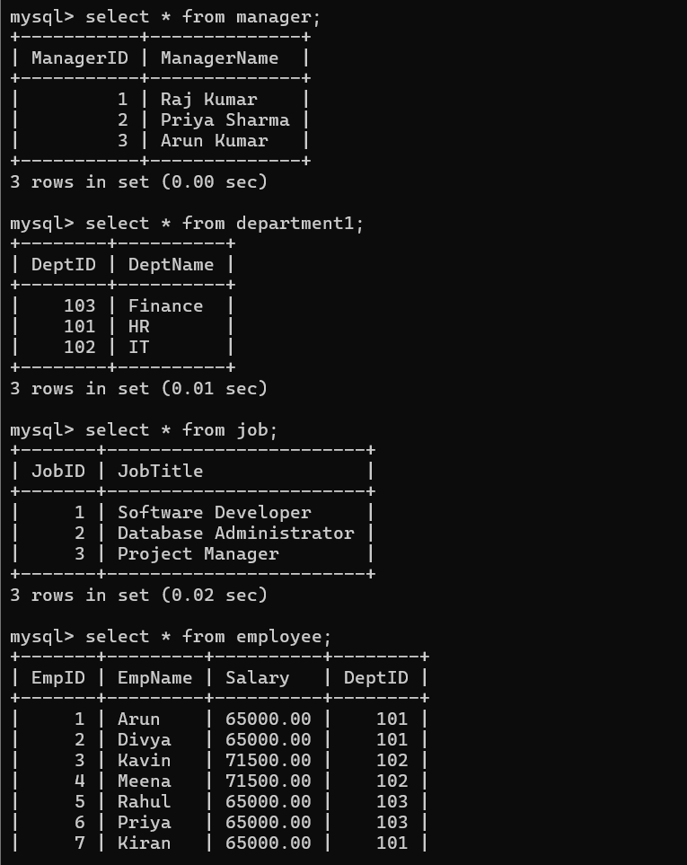

- Case: Library(MemberID, MemberName, BookID, Title, Author, Genre, BorrowDate). Identify MVDs and decompose to 4NF.

ANSWER:

Library — Decompose to 4NF
Relation
Library(MemberID, MemberName, BookID, Title, Author, Genre, BorrowDate)
Suppose a member can have multiple books and multiple independent genres/authors associated with their library preferences. This creates multivalued dependencies.
MVDs
For the simplified independent multivalued case:
MemberID →→ BookID
and
MemberID →→ Genre
These are independent multivalued facts.
4NF Decomposition
MEMBER
Member(MemberID, MemberName)
MEMBER_BOOK
MemberBook(MemberID, BookID, BorrowDate)
BOOK
Book(BookID, Title, Author)
GENRE
BookGenre(BookID, Genre)
The independent multivalued relationships are separated.
Therefore, the resulting relations satisfy 4NF under the stated MVD assumptions.
Note: If Genre is simply a single-valued property of each book, then BookID → Genre, and there is no MVD requiring a 4NF decomposition.

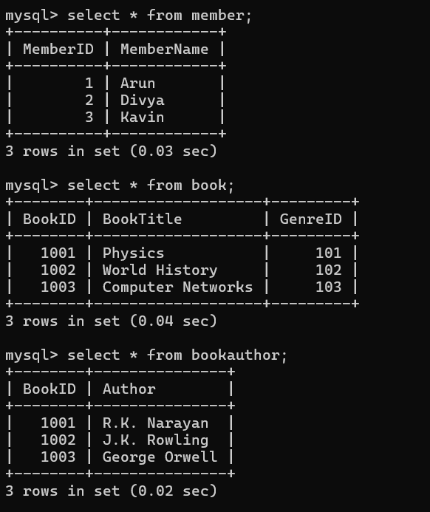

- Analyze a telecom billing schema and identify all candidate keys, primary keys, and functional dependencies before normalization.

ANSWER:
Telecom Billing — Keys and Functional Dependencies
Consider:
Billing(BillID, CustomerID, CustomerName, PhoneNo, PlanID, PlanName, CallID, CallDate, Duration, Rate, Amount)
Functional Dependencies
- BillID → CustomerID, PhoneNo, PlanID
- CustomerID → CustomerName
- PlanID → PlanName, Rate
- CallID → CallDate, Duration
- (CallID, PlanID) → Amount
Candidate Keys
Depending on the business rules:
- BillID
- CustomerID + BillingPeriod if bills are uniquely identified by customer and period
- CallID if every call record is unique
Primary Key
A suitable primary key is:
BillID
Main Dependencies
BillID → CustomerID
CustomerID → CustomerName
PlanID → PlanName
PlanID → Rate
CallID → CallDate
CallID → Duration
Transitive Dependencies
BillID → CustomerID → CustomerName
BillID → PlanID → PlanName, Rate
These should be removed during normalization.

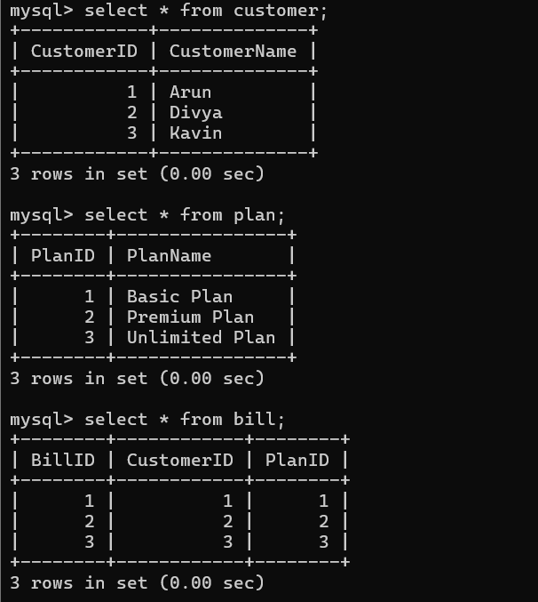

- A retail inventory system has Product(PID, PName, SupplierID, SupplierName, Category, Price, Warehouse). Apply complete normalization.
ANSWER:
Retail Inventory — Complete Normalization
Relation
Product(PID, PName, SupplierID, SupplierName, Category, Price, Warehouse)
Functional Dependencies
- PID → PName, SupplierID, Category, Price, Warehouse
- SupplierID → SupplierName
Candidate Key
PID
1NF
All values are atomic → 1NF.
2NF
Since the key is a single attribute PID, there are no partial dependencies.
Therefore → 2NF.
3NF
There is a transitive dependency:
PID → SupplierID → SupplierName
Decompose:
PRODUCT
Product(PID, PName, SupplierID, Category, Price, Warehouse)
SUPPLIER
Supplier(SupplierID, SupplierName)
Now the relations are in 3NF.
Under the stated dependencies, they are also in BCNF.
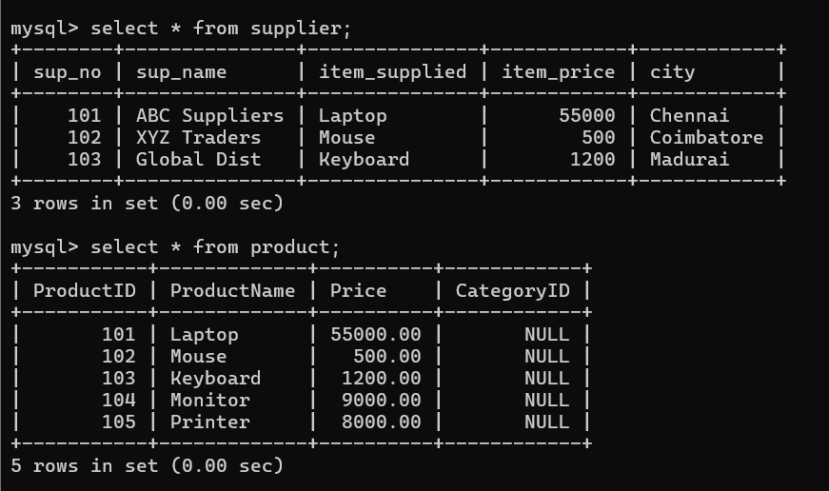

- Study the given poorly normalized schema for a School ERP and propose a fully normalized design up to BCNF with justification.
ANSWER:
Retail Inventory — Complete Normalization
Relation
Product(PID, PName, SupplierID, SupplierName, Category, Price, Warehouse)
Functional Dependencies
- PID → PName, SupplierID, Category, Price, Warehouse
- SupplierID → SupplierName
Candidate Key
PID
1NF
All values are atomic → 1NF.
2NF
Since the key is a single attribute PID, there are no partial dependencies.
Therefore → 2NF.
3NF
There is a transitive dependency:
PID → SupplierID → SupplierName
Decompose:
PRODUCT
Product(PID, PName, SupplierID, Category, Price, Warehouse)
SUPPLIER
Supplier(SupplierID, SupplierName)
Now the relations are in 3NF.
Under the stated dependencies, they are also in BCNF.
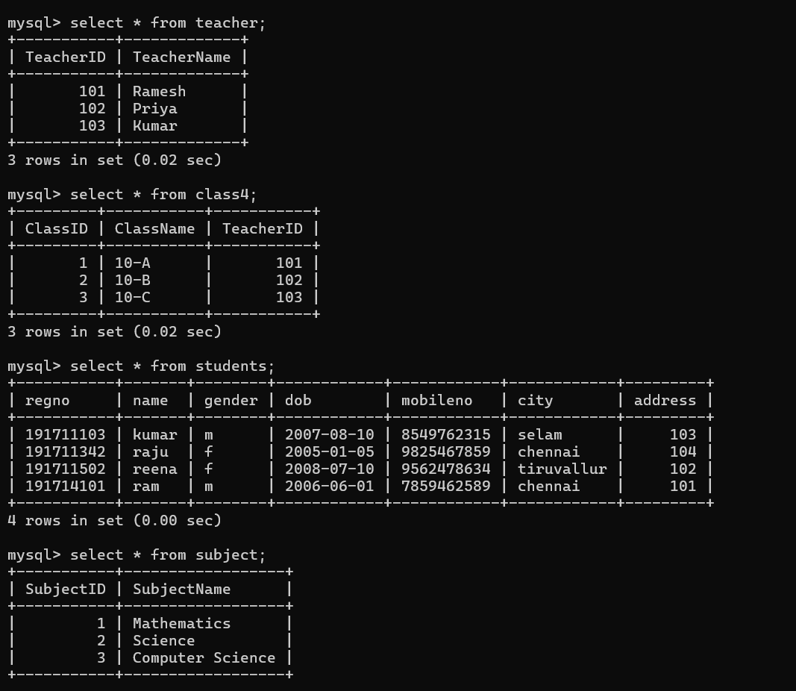

- Given a movie streaming platform schema, identify join dependencies and decompose to 5NF with lossless-join verification.

ANSWER:
Movie Streaming Platform — 5NF
Consider a platform where movies, actors and streaming services have independent relationships:
MovieStream(MovieID, ActorID, PlatformID)
Suppose the business rules allow the three-way relationship to be reconstructed from three pairwise relationships.
Join Dependencies
The relation has the join dependency:
*(MovieID, ActorID), (MovieID, PlatformID), (ActorID, PlatformID)
This means:
MovieStream
=
MovieActor
⋈
MoviePlatform
⋈
ActorPlatform
5NF Decomposition
MOVIE_ACTOR
MovieActor(MovieID, ActorID)
MOVIE_PLATFORM
MoviePlatform(MovieID, PlatformID)
ACTOR_PLATFORM
ActorPlatform(ActorID, PlatformID)
Lossless Join Verification
Joining the three decomposed relations:
MovieActor
⋈ MoviePlatform
⋈ ActorPlatform
reconstructs the original MovieStream relation when the stated join dependency is a valid business constraint.
Thus the decomposition is lossless and removes the nontrivial join dependency.
Final 5NF Design
MovieActor(MovieID, ActorID)
MoviePlatform(MovieID, PlatformID)
ActorPlatform(ActorID, PlatformID)
Therefore, the schema is in 5NF under the stated join-dependency assumption.
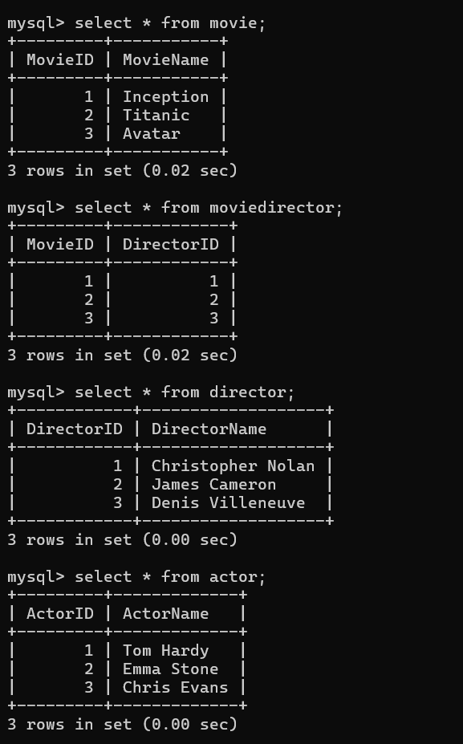

Code of Conduct:
I __M.V.PREETHASHRI(192524476)__ (Name / Reg No) certify that this submission is my original work and that I have adhered to the guidelines specified for this assessment.
I understand that any violation of academic integrity rules will result in disciplinary action.
Signature of the student: M.V.PREETHASHRI

